[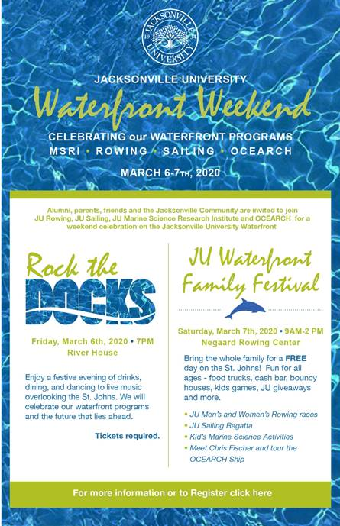](https://nam02.safelinks.protection.outlook.com/?url=https%3A%2F%2Fwww.ju.edu%2Fevents%2Fregistration%2F2020-03-waterfront-celebration.php&data=02%7C01%7Cqwhite%40ju.edu%7Caad2906e57474a25959408d76463c24d%7C9c5bf9df37884b6eba5e6eebbbfab579%7C0%7C0%7C637088251933475172&sdata=aYRjxuEqVPIA0yz9537XnrHj4NpVr%2B8JC9PLQrQSO%2Bc%3D&reserved=0)